The Impact of Amtrak Performance in the Northeast Corridor
Tolulope Ogunbekun & Joseph Sussman
Department of Civil and Environmental Engineering, Massachusetts Institute of Technology, Cambridge, MA

The performance of Amtrak’s Acela and Regional services in the Northeast Corridor (NEC) is a topic that, while frequently discussed as substandard by some travelers, has received minimal attention in the compendium of open source research literature. This brief focuses on Amtrak’s Acela and Regional travel time performance in the last ten years (2005 to 2014).
Amtrak is a vital transportation provider on the Northeast Corridor serving travelers between Boston, MA and Washington, DC, including major cities such as Providence, RI; New Haven, CT; New York, NY; Philadelphia, PA; and Baltimore, MD. In Fiscal Year 2014 (FY 2014), Amtrak had a record high of 11.6 million passengers on the Acela and Regional services combined. However, only 3.9 million passengers arrived at their destination at the scheduled arrival time; that is, 7.4 million passengers experienced delays for a myriad of reasons. This brief evaluates different factors that led to variability in service performance, as well as the impact of service performance on ridership. The authors hopes that this research will inform the ongoing discussion on measures needed to strengthen intercity passenger rail in the Northeast Corridor.

NEC Background
The Northeast Corridor (NEC) is a 457-mile stretch of fully electrified railway line between Boston and Washington D.C. Figure 1 shows the NEC infrastructure ownership. Amtrak owns 79% (363 miles) of the NEC track, and operates (dispatches and maintains the right-of-way) throughout the corridor, except the 56-mile section between New Rochelle, NY. and New Haven, CT. controlled by Metro-North Railroad. The NEC is the busiest railroad in the U.S. both in terms of service frequency and demand. Over 2,200 trains operate on the corridor daily; 2,000 commuter trains, 153 Amtrak intercity passenger trains, and 70 freight trains. Between Amtrak and the commuter trains, there were approximately 750,000 daily riders, and in total about 260 million passenger trips made on the NEC in FY 2014.
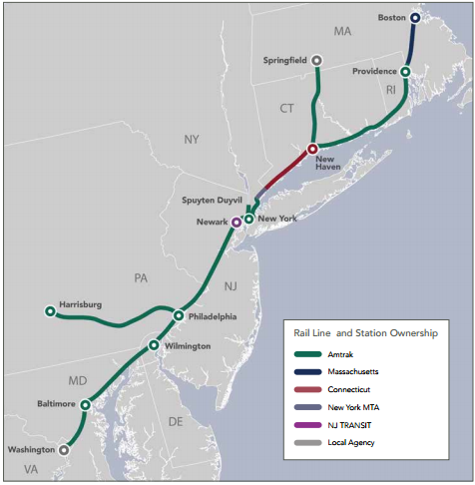
Figure 1. NEC Infrastructure Ownership (Source: NEC Commission)

Acela and Regional Performance Background
The Acela Express (Acela) and Northeast Regional (Regional) are the two main Amtrak services operating along the NEC mainline, and the focus of this research.
Amtrak routinely reports the end-point on-time performance (OTP), which measures the percentage of Acela and Regional trains that arrive at their final destination at the scheduled arrival time. An Acela train is classified as “on time” if it arrives within 10 minutes of its scheduled arrival time, while a Regional train is classified “on time” if it arrives within 10 minutes for trips less than 250 miles, 15 minutes for trips between 251 and 350 miles, and 20 minutes for trips between 351 and 450 miles. In FY 2010, Amtrak together with the Federal Railroad Administration (FRA) set the OTP target at 95% for Acela and 90% for Regional. However, each year, both Acela and Regional have performed below the target.
Figure 2 shows the annual average end-point OTP for Acela compared to the performance target. The black line represents the OTP target for Acela (prior to FY 2010, Amtrak did not have an established on-time target). Between FY 2010 and FY 2014, despite the 10-minute arrival buffer, the annual on-time performances on the Acela service were about 5 to 20 percentage points below the target. The best Acela service performance was experienced in FY 2012 with an annual average OTP of 90% while FY 2014 experienced the worst with an annual average OTP of 75%. In other words, in FY 2014, 1 in 4 Acela trains arrived at their final destination more than the 10 minutes after the scheduled arrival time.
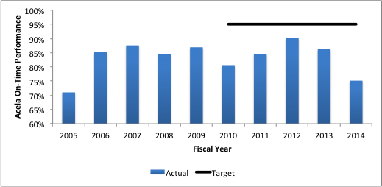
Figure 2. Acela Annual OTP

Despite the lenient buffer and lower OTP goal, Figure 3 shows that the Regional service also underperformed by about 5 to 20 percentage points between FY 2010 and FY 2014. Similar to the Acela, the Regional service experienced the best performance in FY 2012 with an annual average OTP of 88%, and the worst performance in FY 2014 with an annual average OTP of 77%. In this brief, some of the factors leading to travel time variability and underperformance on Amtrak’s Acela and Regional services are discussed.
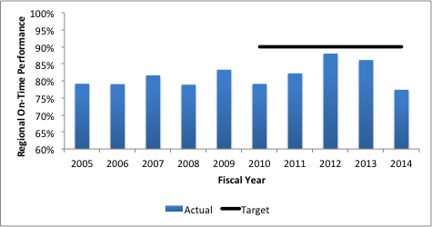
Figure 3. Regional Annual OTP

Factors Influencing Performance Fluctuations
The variation in Amtrak’s service were studied under six main categories: i) seasonality and month of year variations, ii) day of week, and time of day differences, iii) performance variations due to administration, management and control elements, iv) service disruptions due to accidents and incidents (e.g. signal failures, weather-related, track work), v) disturbances due to interference from other trains, and vi) service fluctuations due to capacity levels on trains. The impacts of each of these factors were investigated by analyzing the FY 2005 to FY 2014 historical ridership and train operations data. The data analysis was used to identify the days and trains on which delays were incurred, which are useful for separating systematic trends from the random components in the delays.

Discussion of Results

Seasonality and Month of Year
Figure 4 shows the monthly on-time performance for Acela between FY 2005 and FY 2014. On both Acela and Regional services, there were clear signs of monthly performance variations; winter months typically experienced the best performance, except during severe winter weathers, and summer months typically suffered poorer performance due to heat restriction (which requires trains to run at a slower speed when track temperature exceeds 120 degrees), infrastructural issues (catenary wire drooping) and track work (usually scheduled in good weather months).
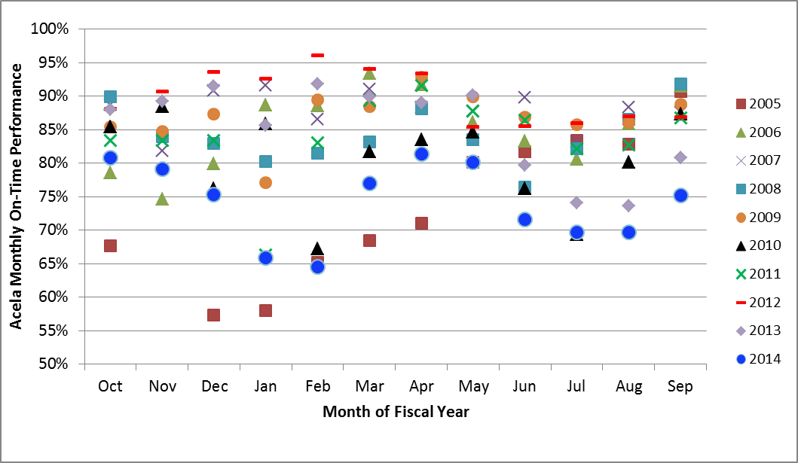
Figure 4. Acela Monthly On-Time Performance

Day of week and Time of Day
Other than Saturday, which usually experienced lower levels of delays, service performance on the Acela and Regional did not appear to vary considerably by day of week.
Time of day was shown to impact Acela and Regional performances as certain morning and evening peak hour trains experienced both high ridership and significant delays. Also, the best and worst performing Acela and Regional trains were usually the same across the years suggesting some systematic issues. Overall, all trains experienced a significant amount of delays, including the first train of the day, which theoretically should be able to achieve on-time arrivals regularly.

Administration, Management and Control Elements (e.g. operating crew, timetable construction, etc.)
The first train analysis served as the proxy to evaluate the effect of administration, management and control elements. The analysis attempted to track detailed station-to-station arrivals and departures of the first Acela and Regional trains over multiple days to identify causes of delay. The analysis revealed that the first train of the day often departed from the originating stations with about 1 to 3 minutes of delay on average, which accumulated and propagated at each consecutive station downstream.
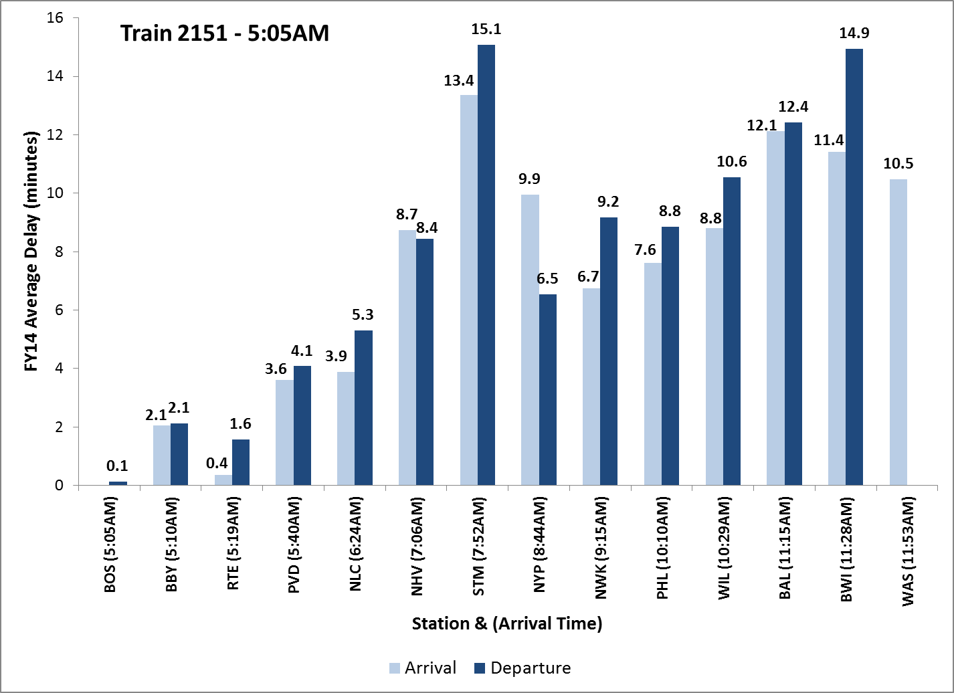
Figure 5. Train 2151 Average FY 14 Delay
For example, Figure 5 shows the average FY 2014 arrival and departure delays for Train 2151 at each successive station on the corridor. Train 2151 is the first southbound Acela train scheduled to depart from Boston South Station (BOS) at 5:05AM and arrive at Washington Union Station (WAS) at 11:53AM with a 15 minute en-route dwell time at New York Penn Station (NYP). In FY 2014, Train 2151 had an OTP of 72% and average delay of 11 minutes. The light blue bars are arrival delays while the dark blue bars represent departure delays.
Overall, the dark blue bars are higher than the light blue bars suggesting that trains accumulated additional delays between arrival at a station and departure from the same station. This is likely due to the fact that terminal time is not scheduled at all en-route stations to account for the time it takes for passenger to get on and off the trains. Additionally, upstream delays on the Acela and Regional seemed to accumulate on some segments and lessen on other segments as a result of flawed timetable segment train speeds and travel times.

Accidents and Incidents (e.g. Signal Failures, Weather-related, Track Work, etc.)
Unanticipated weather-related and third party events were responsible for about 12% of Acela and Regional train delays (based on FY 2012 and FY 2014 analysis). Furthermore, in FY 2012, there was only one major delay caused by an operational issue; however, by FY 2014, about 50% of severe daily delays (delays >1,000 minutes) were associated with equipment and infrastructure issues. This evidences the impact of inadequate track renovation and infrastructure maintenance on the Northeast Corridor in recent years. Furthermore, excluding days with severe weather issues, Amtrak rarely cancels Acela and Regional trains.

Interference From Other Amtrak Trains
On days with severe service interruptions caused by accidents or weather disruptions, delays on one Amtrak train usually cascaded to other trains. However, on a given average day, most Acela and Regional trains experienced delays less than 30 minutes and since Amtrak schedules trains in intervals greater than or equal to 30 minutes, routine delays on one train usually did not cascade to the next scheduled train.

Capacity Levels on Trains
Compared to prior years, in FY 2014, more Acela trains appeared to be near or at capacity in both the north-end and south-end segments of the corridor, especially the trains operated during morning or evening peak periods. The capacity-constrained Acela and Regional trains operated during the peak periods also exhibited poorer performance.

Demand Response to Service Performance
Figure 5 shows the total annual Acela ridership (blue) between FY 2005 and FY 2014 and the annual average OTP (red) from the prior year. The annual demand response to annual performance showed a one-year lagged correlation greater than 0.75. On both the Acela and Regional, the correlation coefficients were sufficiently high to propose that the ridership in a given year are typically associated with service performance from the prior year. However, it is unclear whether the one-year lagged associations are cause-effect relations or simply correlations.
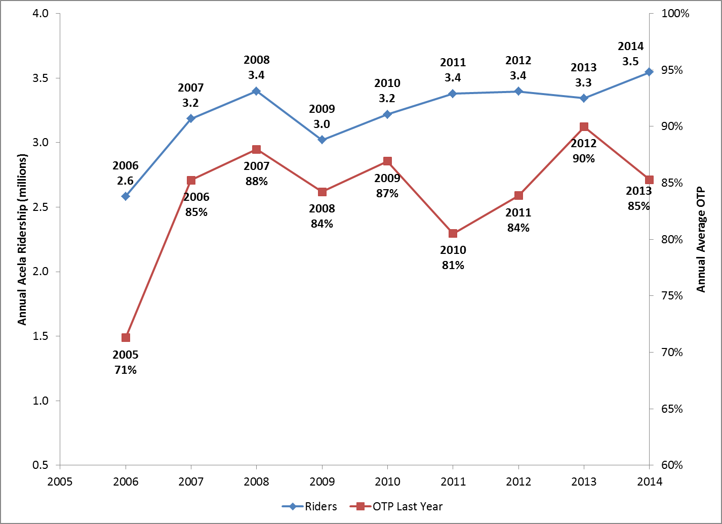
Figure 5. Lagged Annual Ridership to OTP

Conclusions and Recommendations
Figure 2 and Figure 3 highlight the conclusion of the research that both Acela and Regional services are underperforming. The major causes of delays and poor performance were attributed to: (i) timetable construction artifacts such as poorly estimated segment speeds and no dwell time allowances at many stations, (ii) minor avoidable issues such as late departure from originating station, (iii) infrastructure and rolling stock deterioration, and (iv) absence of policies and programs to keep Amtrak accountable to established goals. The findings from the research were used to recommend active steps for Amtrak regarding monitoring and improving service performance in the Northeast Corridor.

Refine Data Records
In September 2013, Amtrak launched a new interactive tool to track daily train operations in real-time. The train tracker provides accurate information about the location of each train en-route, including train speeds, departure time from originating station, and scheduled and actual arrival times at each successive station. The automatic vehicle locators (AVL) data should replace Amtrak’s current train operations database to provide a more accurate record of train performances. This would eliminate the shortcoming of the current dataset, which had missing train information at some stations because the train personnel failed to record the actual arrival or departure times of the train. The AVL data would refine Amtrak’s current data records.

Refine Timetables
The author compared Amtrak historical timetables with current timetables, which showed that Amtrak has not implemented any significant train schedule adjustments in more than 25 years, even when train technology changed. Daily routine delays on both Acela and Regional trains were attributed to timetable artifacts as discussed in the results section. Consequently, Amtrak should use the refined data obtained from the automatic vehicle locator to revamp or in the very least, adjust train timetables. Furthermore, Amtrak should plan to fine-tune the train timetables on an annual basis, and especially when new trains sets and train slots are introduced.

Educate and Reinforce On-Time Culture
While third party delays (e.g. delays caused by weather-related issues and police-activity issues) are for the most part unavoidable, Amtrak-responsible delays (e.g. delays caused by passengers boarding and alighting, delays caused by crew lateness, etc.) should continue to be managed and reduced by educating and reinforcing an on-time culture for operating and managing Amtrak crewmembers. Additionally, Amtrak should continue to monitor day-to-day causes of delays in order to reduce and eliminate minor causes of delays, such as late departure from originating station.

Management, Policies and Programs
Strict policies and programs like PRIIA Section 207 are required to help Amtrak meet established goals. The research showed that even though Amtrak owns most of the track in the Northeast Corridor, both Acela and Regional services experienced an unprecedented high in service performance in FY 2011 and FY 2012 while PRIIA Section 207 was active, and both services have been encountering performance deterioration since PRIIA Section 207 was overturned in FY 2013. In addition to statutory laws like PRIIA, other proven techniques like Six Sigma and Lean could be utilized to improve quality output of train operations by identifying and removing the causes of errors and minimizing variability in service operations.

The authors would like to thank NURail and USDOT for sponsoring this research.

References
[1] Federal Railroad Administration (FRA) & Department of Transportation (DOT), (2009). Metrics and Standards for Intercity Passenger Rail Service.
[2] The NEC Master Plan Working Group. (2010). The Northeast Corridor Infrastructure Master Plan.
[3] Amtrak (2012). The Amtrak Vision for the Northeast Corridor. 2012 Update Report.
[4] Ogunbekun, T. A. (2015). The Impact of Amtrak Performance in the Northeast Corridor (Master’s Thesis, Massachusetts Institute of Technology)

http://www.nec-commission.com/
http://www.amtrak.com/ccurl/412/537/Amtrak-FY2015-Federal-Budget-Request-ATK-14-028,0.pdf
http://www.timetables.org/
http://www.amtrak.com/train-schedules-timetables

